**Peering**

A VPC peering connection is a networking connection between two VPCs that enables you to route traffic between them using private IPv4 addresses or IPv6 addresses. Instances in either VPC can communicate with each other as if they are within the same network. You can create a VPC peering connection between your own VPCs, or with a VPC in another AWS account. The VPCs can be in different Regions (also known as an inter-Region VPC peering connection).


            A VPC peering connection
        

**1.Creating vpc**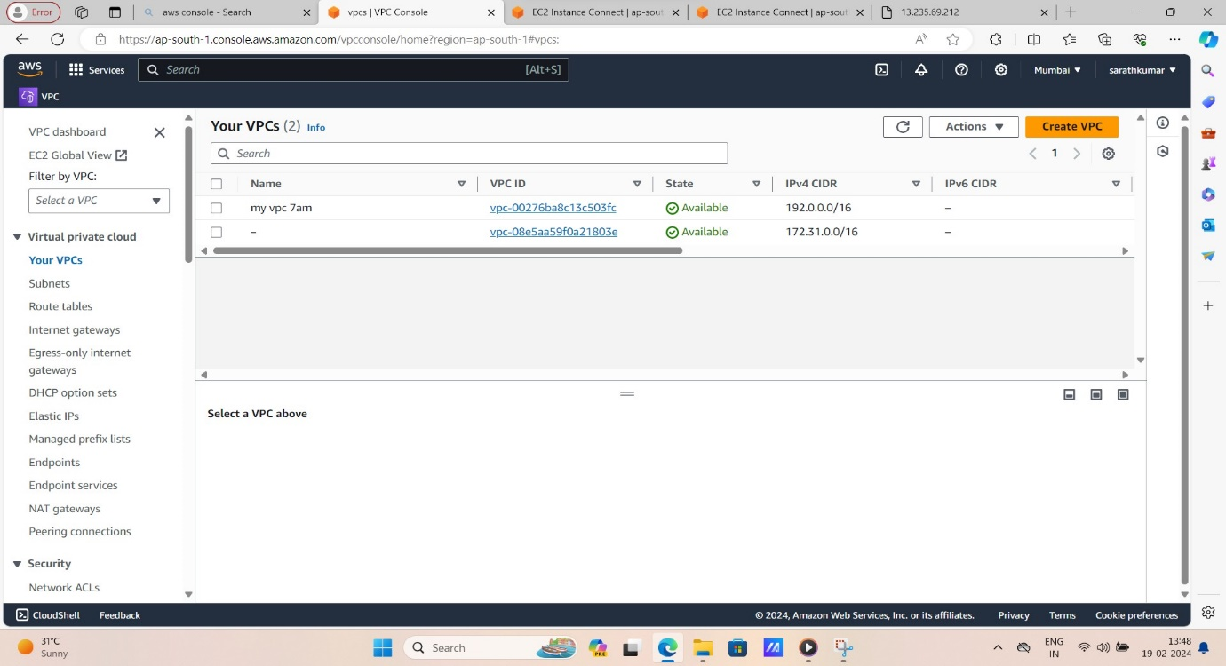

**2.Create one instance**

**Log in in to server and install nginx,and create a file,and proceed to restart,status in nginx process…**

**Copy and past it public ipv4 adress in new tab..the server display your content.**

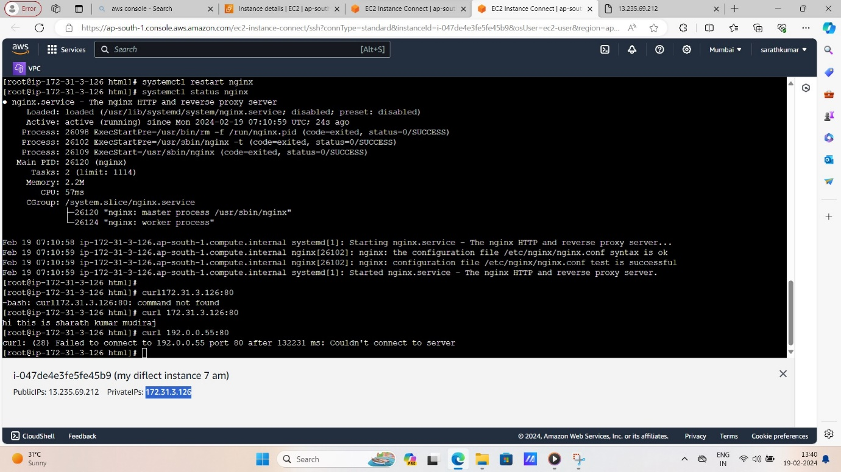

**3.creat second instan**

**Create instance and log in to server directly,and change to root user.**

**Past the private ipv4 adress in the server its not connected.so we go to peering in two vpcs process.** 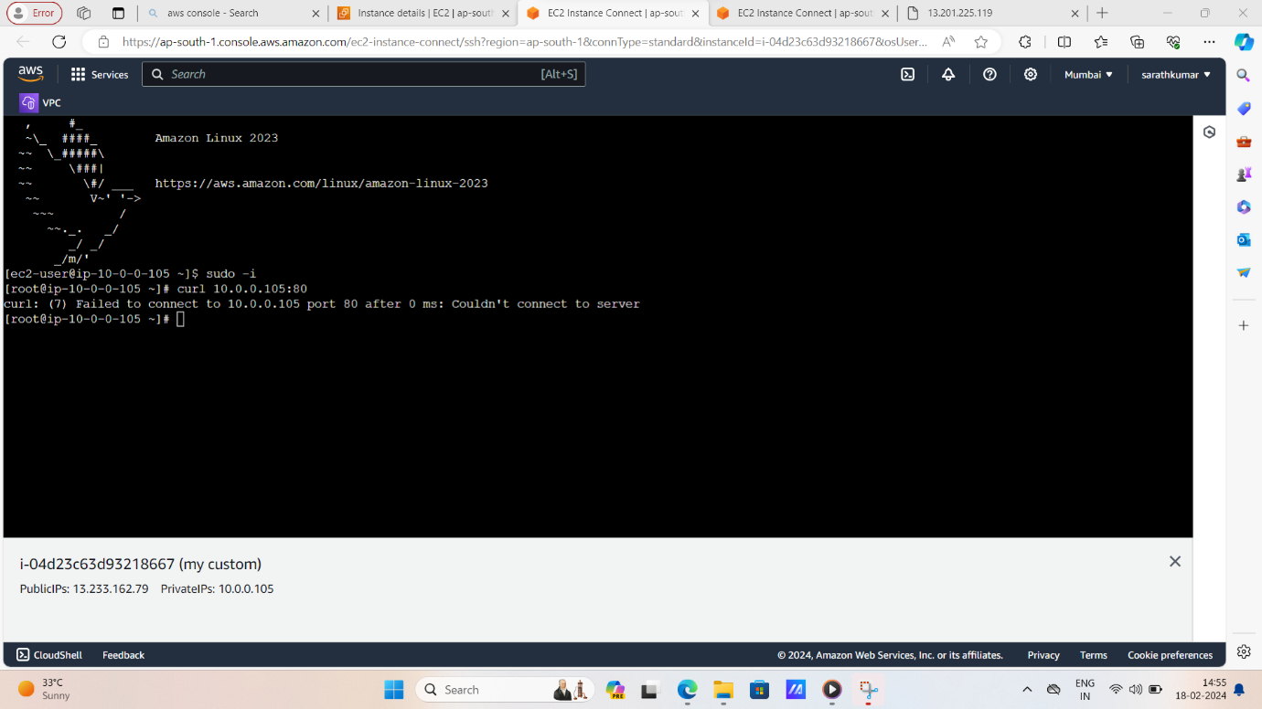

**4.peering connection**

**Go to peering connections,and peering two vpcs,and change the ipv4 connections peering process…..and finally successfully peering connection.**

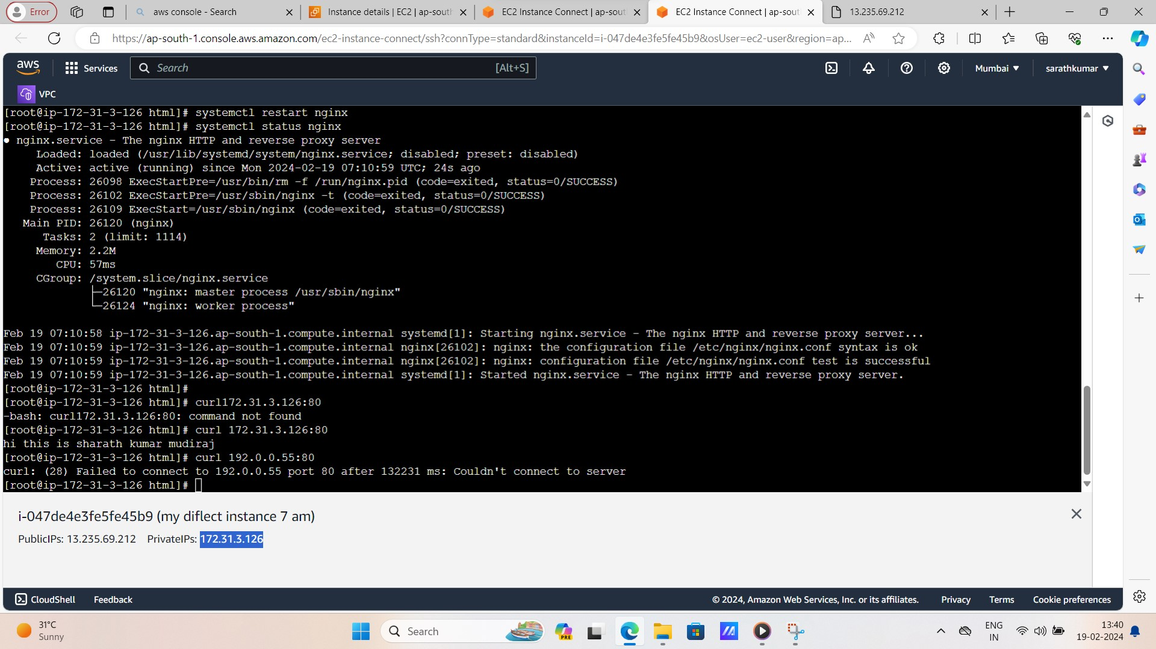

Name-B.sarath kumar

Phn-7702927080